IN404 Unit 6 Assignment: Kernel Analysis
Shubham Raj
Purdue University Global
IN404: Machine Learning
Dr. Sen Baidya
October 23, 2026

Item 1: Python Code and Execution Results
I used the provided IN404_Unit5and6_1.csv and IN404_Unit5and6_2.csv datasets to train a support vector machine (SVM) classifier and visualize its results. I completed every section marked "YOUR CODE HERE." I built the line chart, bar chart, confusion matrix plot (matshow), and scatter plot with matplotlib's pyplot interface (Hunter, 2007; Joshi et al., 2016; McGreggor, 2015), the classification report heatmap with seaborn (Waskom, 2021), and the decision region plot with the mlxtend plot_decision_regions function (Raschka, 2018). I also changed the CSV file paths to load relative to the script's folder so the program runs from any working directory.

Complete Python Code (IN404_Unit6.py)
import pandas as pd
import numpy as np
from pathlib import Path
from sklearn.model_selection import train_test_split
from sklearn import svm
import sys
import matplotlib
matplotlib.use("TkAgg")
import matplotlib.pyplot as plt
from sklearn import metrics
from sklearn.metrics import classification_report, confusion_matrix
import seaborn as sns
from mlxtend.plotting import plot_decision_regions
#Ignoring warnings
if not sys.warnoptions:
import warnings
warnings.simplefilter("ignore")
#Set the writeFunction boolean
#True = write to console
#False = write to file for assignment turnin
PRINT = True
#Open a file handle for assignment results.
if PRINT == False:
f = open("IN404_Unit6.txt", "a")
###############################################
##
##PURPOSE: Write to console or file based on
## the writeFunction variable
## True = write to concole
## False = write to file for assignment turnin
##
##INPUT: Message to write (message1)
## Optional: message2
##
##OUTPUT: None
##
###############################################
def writeFunction(message1, *message2):
#Print to console
if PRINT:
print(message1)
print(message2)
print()
#Print to file for assignment
else:
f.write(str(message1))
f.write(str(message2))
f.write("\n\n")
#Widen the column display
pd.set_option('max_colwidth',500)
#Use portable paths relative to this script's location
DATA_DIR = Path(__file__).resolve().parent
#Read reviews into a DataFrame
df1 = pd.read_csv(DATA_DIR / 'IN404_Unit5and6_1.csv', encoding='unicode-escape')
#Read reviews into a DataFrame
df2 = pd.read_csv(DATA_DIR / 'IN404_Unit5and6_2.csv', encoding='unicode-escape')
#Plot frequency count over time
date_line = df1['Date'].value_counts().sort_index()
ax = date_line.plot(figsize=(12,6), title="Count by Time")
ax.set_xlabel("Date")
ax.set_ylabel("Frequency")
plt.show()
#Plot the numbers over time
count = df1.groupby(['Date', 'Number1']).size()
ax = count.plot(figsize=(12,6), title="Numbers over Time")
ax.set_xlabel("Date/Number")
ax.set_ylabel("Frequency")
plt.show()
#Bar chart showing number frequency
ax = df1['Number1'].value_counts().plot(kind='bar',
figsize=(12,6),
title="Frequency of Numbers")
ax.set_xlabel("Number")
ax.set_ylabel("Count")
plt.show()
###################################
#Convert object to datetime
df1['Date'] = pd.to_datetime(df1['Date'])
#Convert datetime to float
df1['DATE_NUM'] = (df1['Date'] - df1['Date'].min()) / np.timedelta64(1,'D')
############### X ##########################
writeFunction("########## X ############")
#Define X
feature_cols = ['Number1','DATE_NUM']
#Add all rows from the feature columns into X
X = df1.loc[:, feature_cols]
############### y #######################
writeFunction("########## y ############")
#Define y
y = df2['Number1']
##################### TRAIN/TEST Split ################
writeFunction("########## Train/test split ############")
#Split the new DataFrame into training and testing sets
X_train, X_test, y_train, y_test = train_test_split(X, y, random_state=1)
writeFunction("########## SVM ############")
#Create a svm Classifier
# decision_function_shape'ovo', 'ovr', default='ovr'
# Whether to return a one-vs-rest ('ovr') decision function of
# shape (n_samples, n_classes) as all other classifiers,
# or the original one-vs-one ('ovo') decision function
# of libsvm which has shape (n_samples, n_classes * (n_classes - 1) / 2).
# However, one-vs-one ('ovo') is always used as multi-class strategy.
# Changed in version 0.19: decision_function_shape is 'ovr' by default.
# New in version 0.17: decision_function_shape='ovr' is recommended.
# Changed in version 0.17: Deprecated decision_function_shape='ovo' and None.
clf = svm.SVC(decision_function_shape='ovr')
#Train the model using the training sets
clf.fit(X_train, y_train)
#Print the SVM score
writeFunction("SVM score", clf.score(X, y))
############# Predictions #################
#Predict the response for test dataset
y_pred = clf.predict(X_test)
#Print the prediction for the X_test set
writeFunction("Predict value", y_pred)
#Predict number 1 and day 0
writeFunction("Prediction for number 1, and day 0", clf.predict([[1,0]]))
#Predict number 1 and day 2
writeFunction("Prediction for number 1, and day 2", clf.predict([[1,2]]))
#Predict number 2 and day 2
writeFunction("Prediction for number 2, and day 2", clf.predict([[2,2]]))
#Predict number 3 and day 1
writeFunction("Prediction for number 3, and day 1", clf.predict([[3,1]]))
#Print the accuracy score
writeFunction("Accuracy score", metrics.accuracy_score(y_test, y_pred))
############ Confusion Matrix ##################
#Create and print the confusion matrix
writeFunction("Confusion matrix")
cm = confusion_matrix(y_test,y_pred)
writeFunction(cm)
#Plot the confusion matrix using matshow
plt.matshow(cm)
plt.title("Confusion Matrix")
plt.colorbar()
plt.show()
############### Classification report #################
#Create and print the classification report
writeFunction("Classification report")
cr = classification_report(y_test,y_pred, output_dict=True)
writeFunction(cr)
#Plot the classification report using a heatmap and seaborn
ax = plt.axes()
sns.heatmap(pd.DataFrame(cr).iloc[:-1, :].T, annot=True, ax=ax)
ax.set_title('Heatmap for Classification Report')
plt.show()
############### Decision Boundaries #################
#Plot the decision boundaries using plot_decision_regions
plot_decision_regions(X=X.values,
y=y.values,
clf=clf,
legend=4)
# Update plot object with X/Y axis labels and Figure Title
plt.xlabel(X.columns[0], size=14)
plt.ylabel(X.columns[1], size=14)
plt.title('SVM Decision Regions', size=20)
plt.show()
############### Scatter Plot #################
#Visualize the scatter plot using scatter function in PyPlot
plt.scatter(X.iloc[:, 0], X.iloc[:, 1], c=y, s=50, cmap='rainbow')
plt.xlabel(X.columns[0], size=14)
plt.ylabel(X.columns[1], size=14)
plt.title('Scatter Plot', size=20)
plt.colorbar();
plt.show()
#Open a file handle for assignment results.
if PRINT == False:
f.close()

Execution Screenshots
These screenshots show the plot windows that opened when I ran IN404_Unit6.py, followed by the terminal output from the same run.
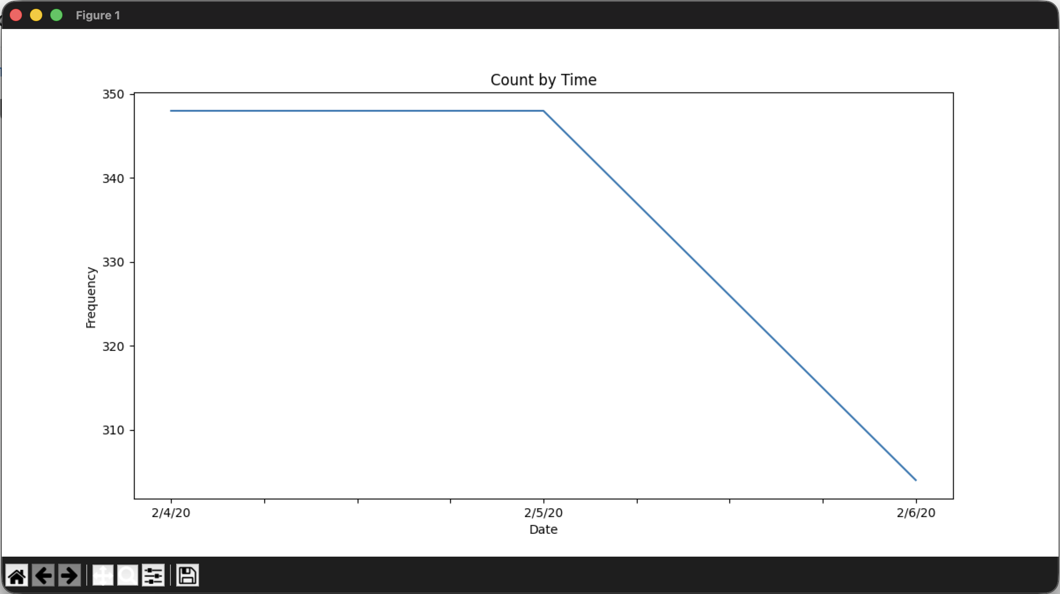
Figure 1: Count by Time — Frequency count of records over time.
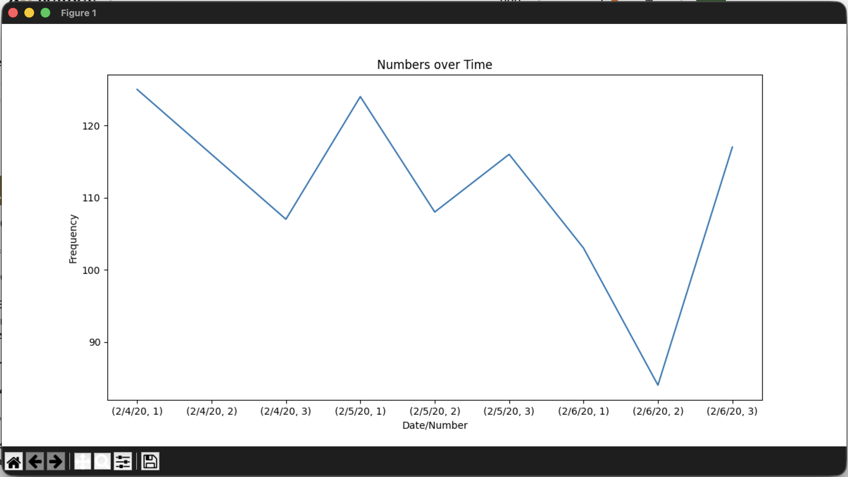
Figure 2: Numbers over Time — Frequency of each Date/Number combination.
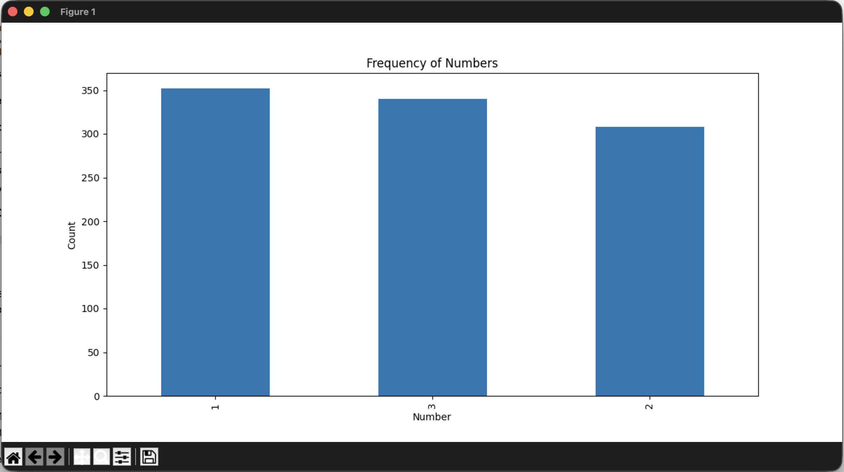
Figure 3: Frequency of Numbers — Bar chart showing the count of each number.
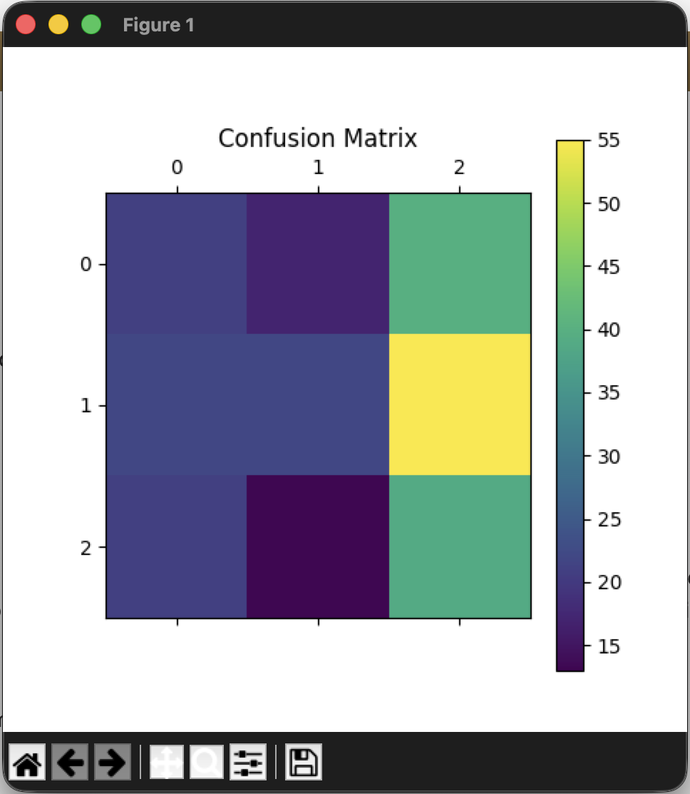
Figure 4: Confusion Matrix — Visual representation of the SVM confusion matrix.
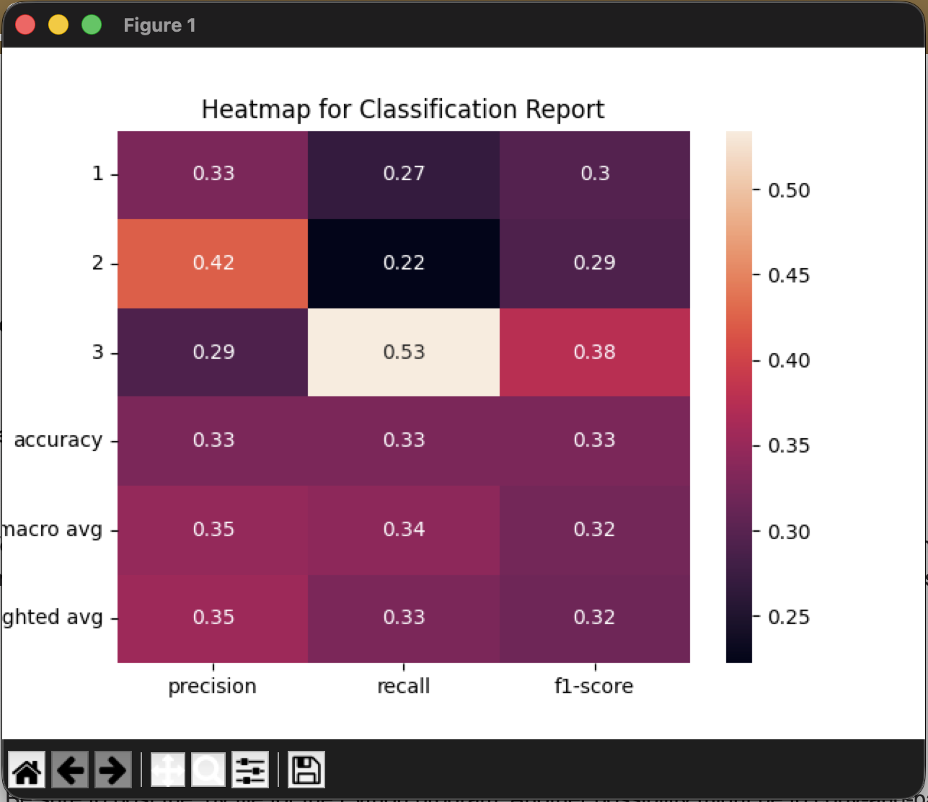
Figure 5: Heatmap for Classification Report — Precision, recall, and F1-score heatmap.
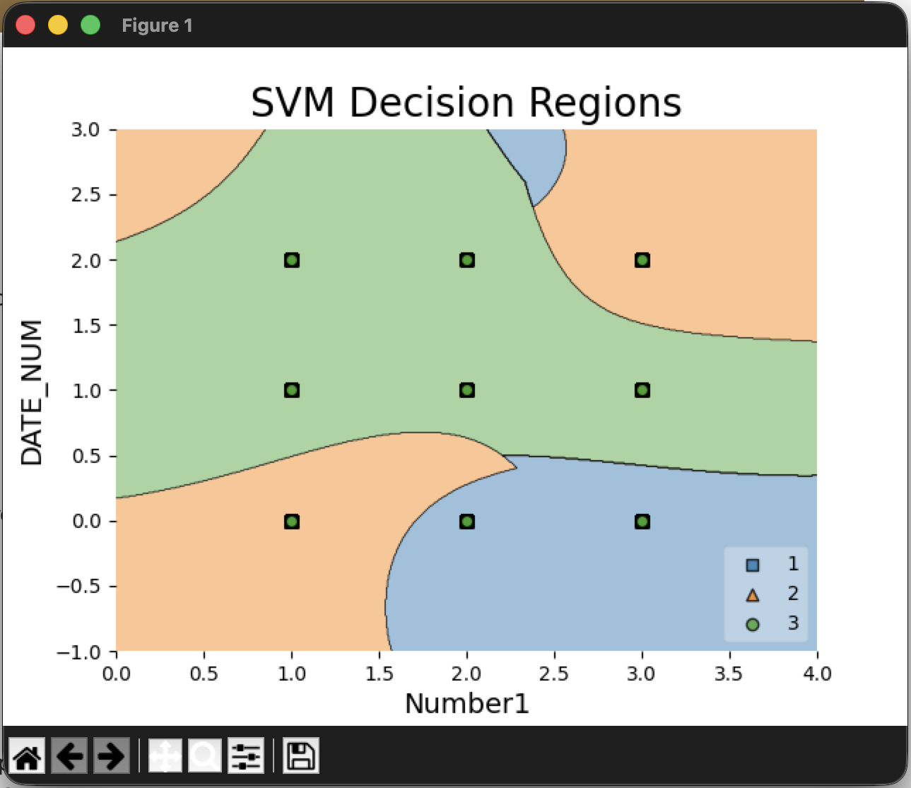
Figure 6: SVM Decision Regions — Decision boundaries of the SVM classifier.
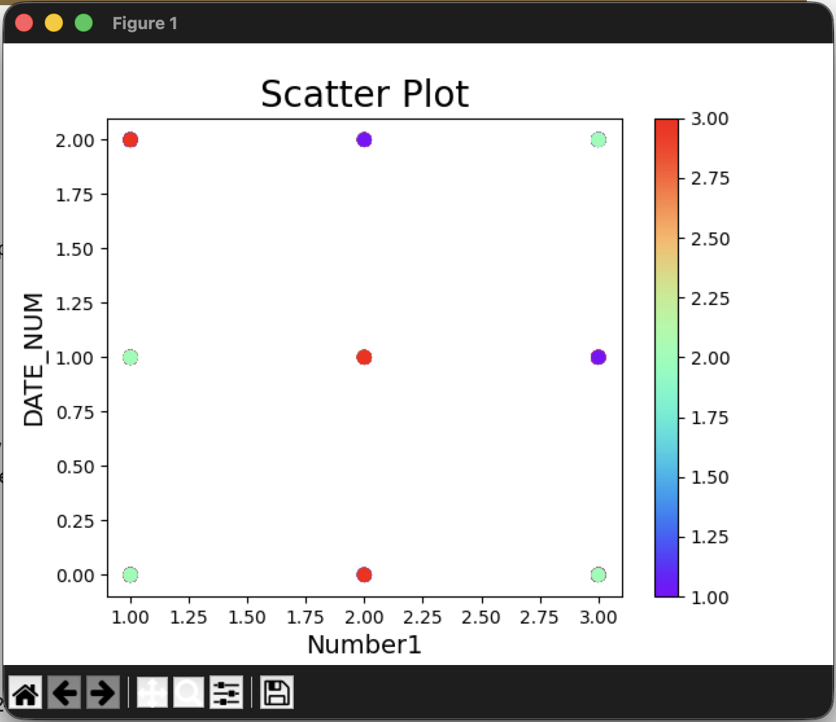
Figure 7: Scatter Plot — Distribution of data points colored by class.

Console Output
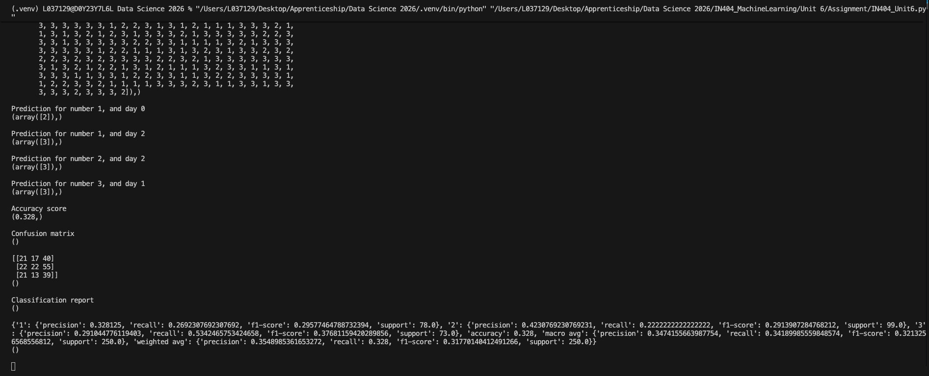
Figure 8: Terminal output from the same run (the full console text follows below).
########## X ############
()
########## y ############
()
########## Train/test split ############
()
########## SVM ############
()
SVM score
(0.371,)
Predict value
(array([2, 3, 3, 3, 3, 3, 2, 2, 3, 3, 3, 3, 1, 3, 2, 3, 1, 1, 3, 3, 3, 3,
3, 3, 3, 3, 2, 1, 3, 1, 3, 3, 3, 3, 2, 3, 3, 2, 3, 1, 1, 3, 2, 2,
2, 2, 3, 1, 2, 1, 3, 3, 1, 3, 1, 2, 3, 3, 3, 1, 1, 3, 1, 3, 1, 3,
3, 3, 3, 3, 3, 3, 1, 2, 2, 3, 1, 3, 1, 2, 1, 1, 1, 3, 3, 3, 2, 1,
1, 3, 1, 3, 2, 1, 2, 3, 1, 3, 3, 3, 2, 1, 3, 3, 3, 3, 3, 2, 2, 3,
3, 3, 1, 3, 3, 3, 3, 3, 2, 2, 3, 3, 1, 1, 1, 1, 3, 2, 1, 3, 3, 3,
3, 3, 3, 3, 3, 1, 2, 2, 1, 1, 1, 3, 1, 3, 2, 3, 1, 3, 3, 2, 3, 2,
2, 2, 3, 2, 3, 2, 3, 3, 3, 3, 2, 2, 3, 2, 1, 3, 3, 3, 3, 3, 3, 3,
3, 1, 3, 2, 1, 2, 2, 1, 3, 1, 2, 1, 1, 1, 3, 2, 3, 3, 1, 1, 3, 1,
3, 3, 3, 1, 1, 3, 3, 1, 2, 2, 3, 3, 1, 1, 3, 2, 2, 3, 3, 3, 3, 1,
1, 2, 2, 3, 3, 2, 1, 1, 1, 1, 3, 3, 3, 2, 3, 1, 1, 3, 3, 1, 3, 3,
3, 3, 3, 2, 3, 3, 3, 2]),)
Prediction for number 1, and day 0
(array([2]),)
Prediction for number 1, and day 2
(array([3]),)
Prediction for number 2, and day 2
(array([3]),)
Prediction for number 3, and day 1
(array([3]),)
Accuracy score
(0.328,)
Confusion matrix
()
[[21 17 40]
[22 22 55]
[21 13 39]]
()
Classification report
()
{'1': {'precision': 0.328125, 'recall': 0.2692307692307692, 'f1-score': 0.29577464788732394, 'support': 78.0}, '2': {'precision': 0.4230769230769231, 'recall': 0.2222222222222222, 'f1-score': 0.2913907284768212, 'support': 99.0}, '3': {'precision': 0.291044776119403, 'recall': 0.5342465753424658, 'f1-score': 0.37681159420289856, 'support': 73.0}, 'accuracy': 0.328, 'macro avg': {'precision': 0.3474155663987754, 'recall': 0.34189985559848574, 'f1-score': 0.3213256568556812, 'support': 250.0}, 'weighted avg': {'precision': 0.3548985361653272, 'recall': 0.328, 'f1-score': 0.31770140412491266, 'support': 250.0}}
()

Item 2: What Is a Confusion Matrix?
A confusion matrix is a table that summarizes how well a classification model's predictions match the actual class labels (Sokolova & Lapalme, 2009). In scikit-learn's confusion_matrix function, which I used in my program, each row represents an actual class and each column represents a predicted class (Pedregosa et al., 2011). The diagonal cells count the correct predictions for each class, and the off-diagonal cells count the misclassifications.
The confusion matrix is the starting point for calculating performance measures such as accuracy, precision, recall, and F1-score (Sokolova & Lapalme, 2009). It is especially useful in multi-class problems because it shows not only how many predictions were wrong but also which classes the model confuses with one another, a pattern that a single accuracy number would hide.

Item 3: Confusion Matrix Output Description
The confusion matrix output from the SVM classifier is a 3×3 matrix because there are three classes (1, 2, and 3):
 | Predicted 1 | Predicted 2 | Predicted 3
Actual 1 | 21 | 17 | 40
Actual 2 | 22 | 22 | 55
Actual 3 | 21 | 13 | 39

The diagonal values (21, 22, and 39) are the correct predictions for classes 1, 2, and 3. Everything off the diagonal is a misclassification. The largest errors are in the third column: 40 actual class 1 samples and 55 actual class 2 samples were predicted as class 3. The model predicted class 3 for 134 of the 250 test samples even though only 73 of them were actually class 3, so it is strongly biased toward that class. In total, 82 of the 250 test samples were classified correctly, an accuracy of 32.8%. That is no better than random guessing for three classes (about 33.3%), and it is worse than always predicting the most common test class, class 2, which would score 39.6% (99 of 250). This tells me the model has not learned a useful pattern from these features. Figure 4 shows the same matrix as a color grid, where the brightest cell is the 55 actual class 2 samples predicted as class 3 and the right-hand column stands out as the class 3 bias.

Item 4: What Is a Classification Report?
A classification report summarizes the main evaluation measures for a classification model, broken down by class (Pedregosa et al., 2011). It reports four measures (Sokolova & Lapalme, 2009):
- Precision: The share of the model's predictions for a class that were correct, TP / (TP + FP). It answers: "Of all the instances the model predicted as this class, how many were correct?"
- Recall: The share of a class's actual instances that the model found, TP / (TP + FN). It answers: "Of all the actual instances of this class, how many did the model correctly identify?"
- F1-score: The harmonic mean of precision and recall, which balances false positives against false negatives in a single number.
- Support: The number of actual instances of each class in the test set.
I use the classification report to see how well a model performs on each class, not just overall. It also includes a macro average, which weights every class equally, and a weighted average, which weights each class by its support, so it shows whether a model is neglecting smaller classes.

Item 5: Classification Report Output Description
The classification report output is as follows:
 | Precision | Recall | F1-Score | Support
Class 1 | 0.33 | 0.27 | 0.30 | 78
Class 2 | 0.42 | 0.22 | 0.29 | 99
Class 3 | 0.29 | 0.53 | 0.38 | 73
Accuracy |  |  | 0.33 | 250
Macro Avg | 0.35 | 0.34 | 0.32 | 250
Weighted Avg | 0.35 | 0.33 | 0.32 | 250

Class 2 has the highest precision (0.42), meaning when the model predicts class 2 it is correct 42% of the time. However, class 2 has the lowest recall (0.22), meaning it only identifies 22% of actual class 2 instances. Class 3 has the highest recall (0.53) and highest F1-score (0.38), but the lowest precision (0.29), confirming the model's bias toward predicting class 3. The overall accuracy of 32.8% and the low macro-average F1-score of 0.32 indicate that the SVM model with the default RBF kernel does not effectively separate these three classes with the given features. Figure 5 shows the same values as a heatmap, where the lightest cell is class 3's recall of 0.53 and the darkest is class 2's recall of 0.22.

Item 6: Numbers over Time Visualization
Using the "Numbers over Time" visualization (Figure 2), I can answer the following questions:

Which date/number combination had the highest frequency?
The date/number combination with the highest frequency is 2/4/20, Number 1.

What is the approximate frequency value?
The approximate frequency value for this combination is 125.

Which date/number combination had the lowest frequency?
The date/number combination with the lowest frequency is 2/6/20, Number 2.

What is the approximate frequency value?
The approximate frequency value for this combination is 84.

Item 7: Frequency of Numbers Bar Chart
Using the "Frequency of Numbers" bar chart (Figure 3), the number with the lowest frequency is Number 2, with a count of approximately 308. In comparison, Number 1 has a count of 352 and Number 3 has a count of 340.

Item 8: Decision Region Plot

What is the purpose of the plot?
The decision region plot (Figure 6) shows the decision boundaries the SVM classifier learned (Raschka, 2018). It divides the two-dimensional feature space (Number1 on the x-axis and DATE_NUM on the y-axis) into colored regions, and each color is the class the model would predict for any point in that region. Its purpose is to show how the classifier partitions the feature space and where the boundaries between predicted classes lie.

What do the results tell you?
The decision regions are curved and irregular, which is typical of the default radial basis function (RBF) kernel. The kernel lets the SVM separate the classes in a higher-dimensional space, so the boundaries look nonlinear when projected back onto the two original features (Cortes & Vapnik, 1995). Class 3 (green) covers the widest band, including every point with DATE_NUM = 1 and most of DATE_NUM = 2. Class 1 (blue) takes the DATE_NUM = 0 points for Number1 = 2 and 3, and class 2 (orange) takes the points (Number1 = 1, DATE_NUM = 0) and (Number1 = 3, DATE_NUM = 2). This matches the confusion matrix, where class 3 was by far the most frequent prediction.
The plot also shows why the model performs poorly. Number1 only takes the values 1 to 3 and DATE_NUM only takes 0 to 2, so all 1,000 samples land on just nine grid points. Each grid point holds a nearly even mix of all three target classes (roughly 26% to 41% each), so the markers stack on top of one another and only the class 3 circle, which is drawn last, is visible. Because every location in the feature space contains all three labels in similar proportions, no boundary can separate them. The best the SVM can do is assign each grid point to whichever class was slightly more common there in the training data. I conclude that Number1 and DATE_NUM carry almost no information about the target, and that changing the kernel or tuning the model would not fix this; better features would be needed.

References
Cortes, C., & Vapnik, V. (1995). Support-vector networks. Machine Learning, 20(3), 273–297. https://doi.org/10.1007/BF00994018
Hunter, J. D. (2007). Matplotlib: A 2D graphics environment. Computing in Science & Engineering, 9(3), 90–95. https://doi.org/10.1109/MCSE.2007.55
Joshi, P., Hearty, J., Sjardin, B., Massaron, L., & Boschetti, A. (2016). Python: Real world machine learning. Packt Publishing.
McGreggor, D. M. (2015). Mastering matplotlib. Packt Publishing.
Pedregosa, F., Varoquaux, G., Gramfort, A., Michel, V., Thirion, B., Grisel, O., Blondel, M., Prettenhofer, P., Weiss, R., Dubourg, V., Vanderplas, J., Passos, A., Cournapeau, D., Brucher, M., Perrot, M., & Duchesnay, E. (2011). Scikit-learn: Machine learning in Python. Journal of Machine Learning Research, 12, 2825–2830. https://jmlr.org/papers/v12/pedregosa11a.html
Raschka, S. (2018). MLxtend: Providing machine learning and data science utilities and extensions to Python's scientific computing stack. Journal of Open Source Software, 3(24), 638. https://doi.org/10.21105/joss.00638
Sokolova, M., & Lapalme, G. (2009). A systematic analysis of performance measures for classification tasks. Information Processing & Management, 45(4), 427–437. https://doi.org/10.1016/j.ipm.2009.03.002
Waskom, M. L. (2021). seaborn: Statistical data visualization. Journal of Open Source Software, 6(60), 3021. https://doi.org/10.21105/joss.03021

